**CRM APPLICATION FOR JEWEL MANAGEMENT - (Developer)**

**College Name: Sri Vasavi College (SFW)**

**College Code: BRU17**

**TEAM ID:**

**TEAM MEMBERS:**

**Team Leader : Surya S**

**Email: suryas2023@gmail.com**

**Team member : Powsthina J**

**Email: powsthinajebastian@gmail.com**

**Team member : TamilSelvi R**

**Email: tamilselvi72972@gmail.com**

**Team member : Dhamotharan P**

**Email: mrdhamo395@gmail.com**

**Project Description:**

The Jewel Inventory System is a comprehensive software Solution designed to streamline and manage the inventory and sales processes of a jewellery store or a jewellery manufacturer. The system aims to provide an efficient and user-friendly solution to track and control the inventory of various jewellery items, maintain accurate records, and facilitate seamless sales transactions**.**

**As a team We’ve learned,**

* Real Time Salesforce Project
* Data Modelling
* Creating an Application
* User Interface Customization
* Object & Relationship in Salesforce
* Formula fields and Validation rules.
* Field Dependencies
* Record Types
* Cross object formula fields.
* Conditional formatting.
* Flows
* Email alerts and email templates
* Reports & Dashboards

**Purpose**

A CRM application's purpose for jewel management is to organize customer data, streamline sales and marketing efforts, personalize customer experiences, and improve overall customer retention and loyalty. It helps to track purchase history and preferences, manage special occasions like birthdays and anniversaries, automate marketing tasks, nurture leads, and gain insights into sales performance to boost revenue and foster stronger customer relationships.

**DEVELOPMENT PHASE**

* **Salesforce**

Creating Developer Account:

By using this URL - <https://www.salesforce.com/form/developer-signup/?d=pb>

**Account Activation**

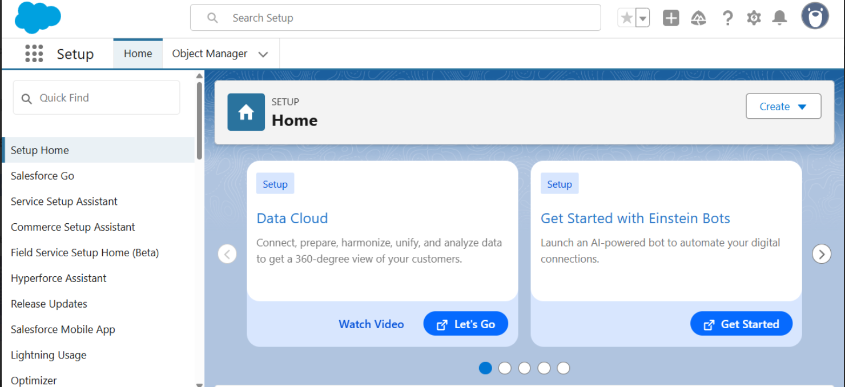

* **Object**

**Create Jewel Customer Object**

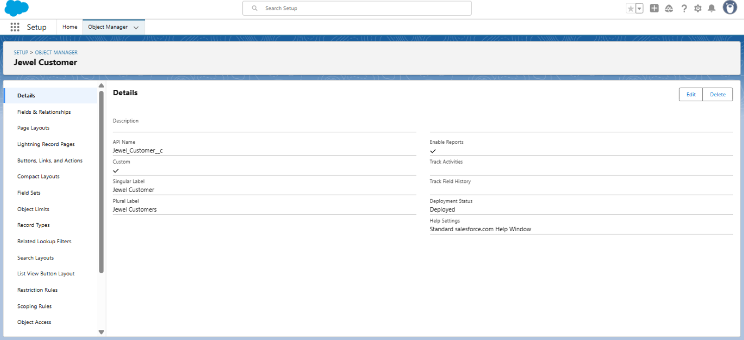

**Create Item Object**

* **Tabs**

**Creating a Custom Tab For (Jewel Customer. Item, Customer Order, Price ,Billing Objects)**

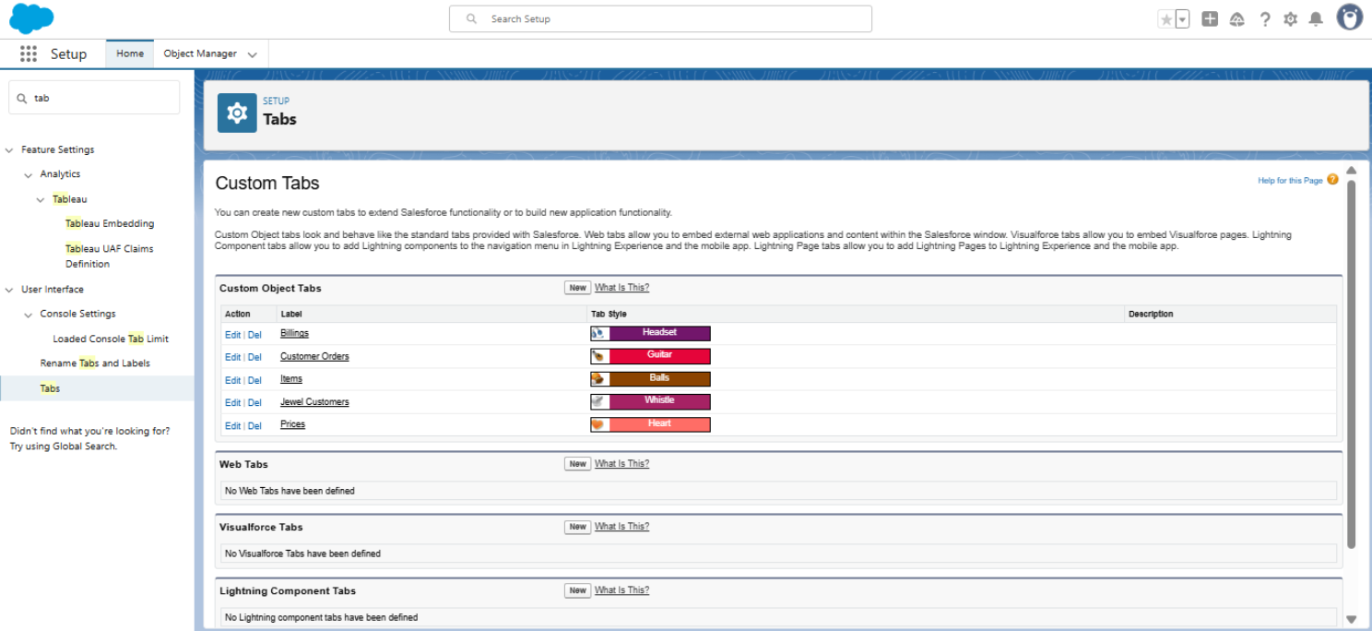

* **The Lightning App**

**Create a Lightning App**

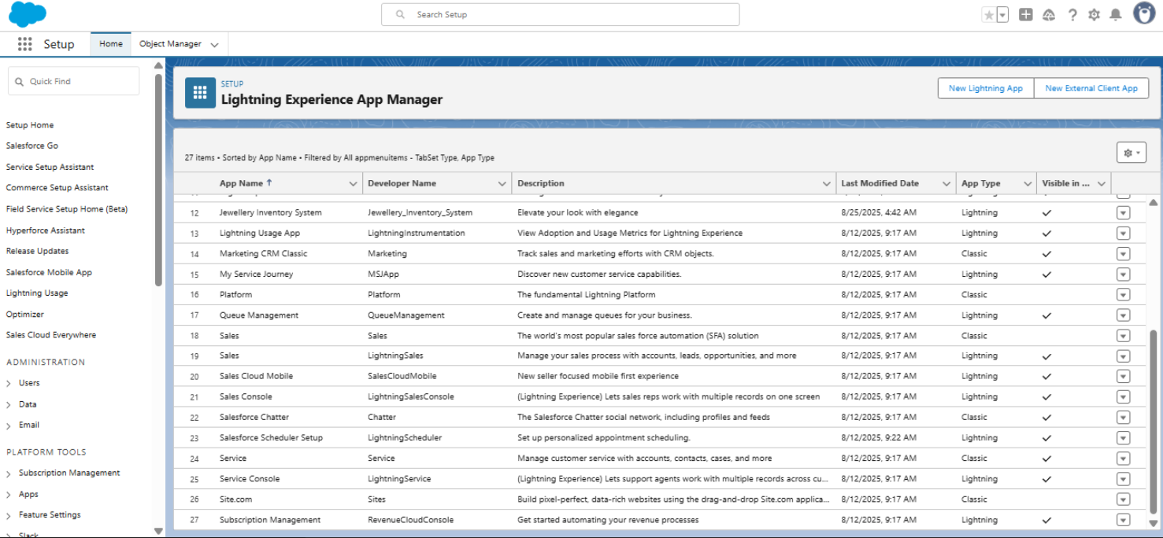

* **Fields**

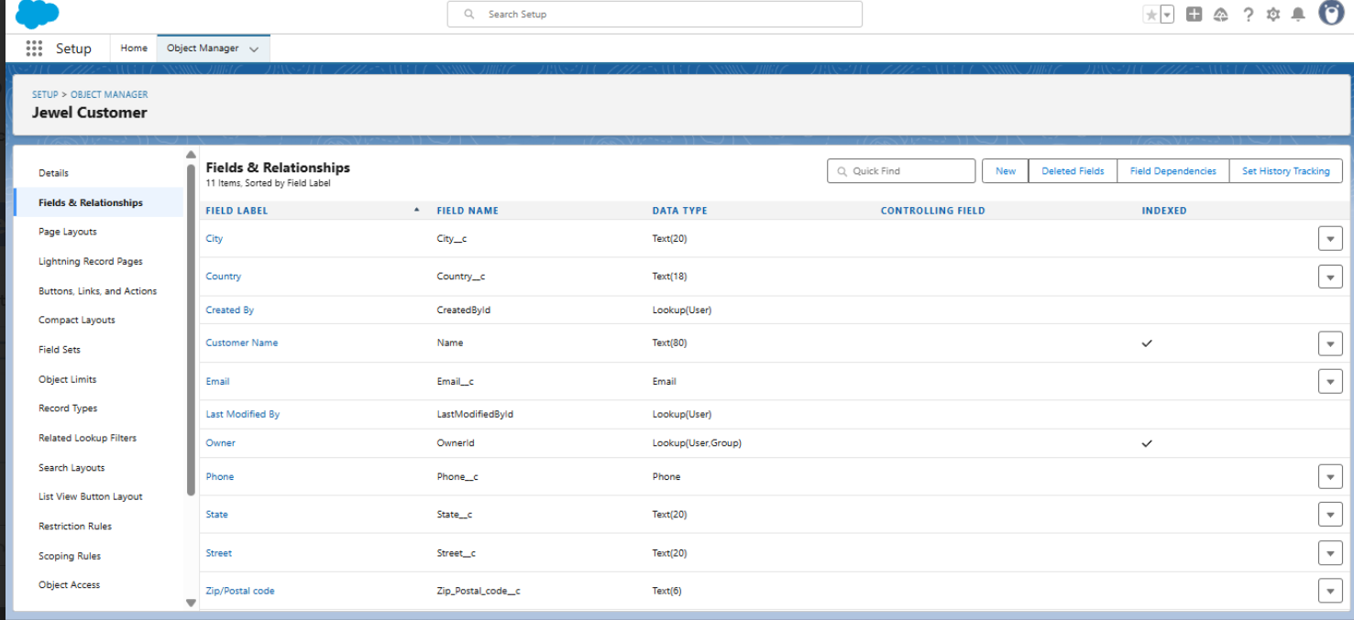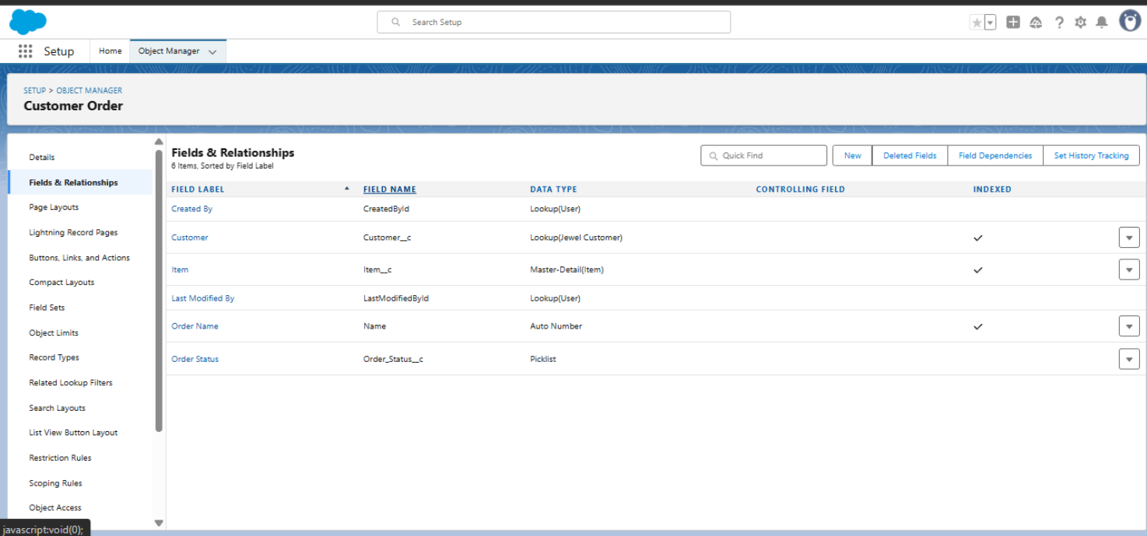

* **Profiles**

**Gold Smith Profile**

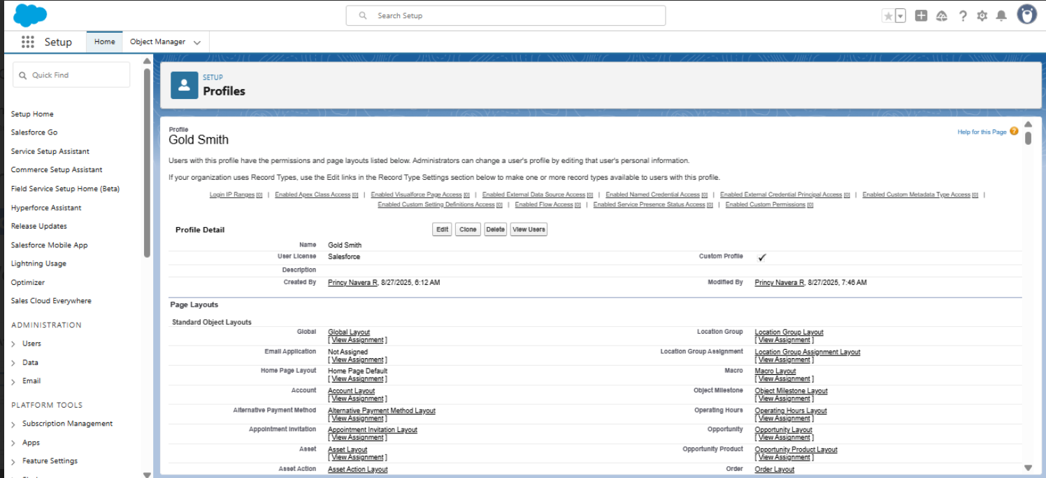

**Worker Profile**

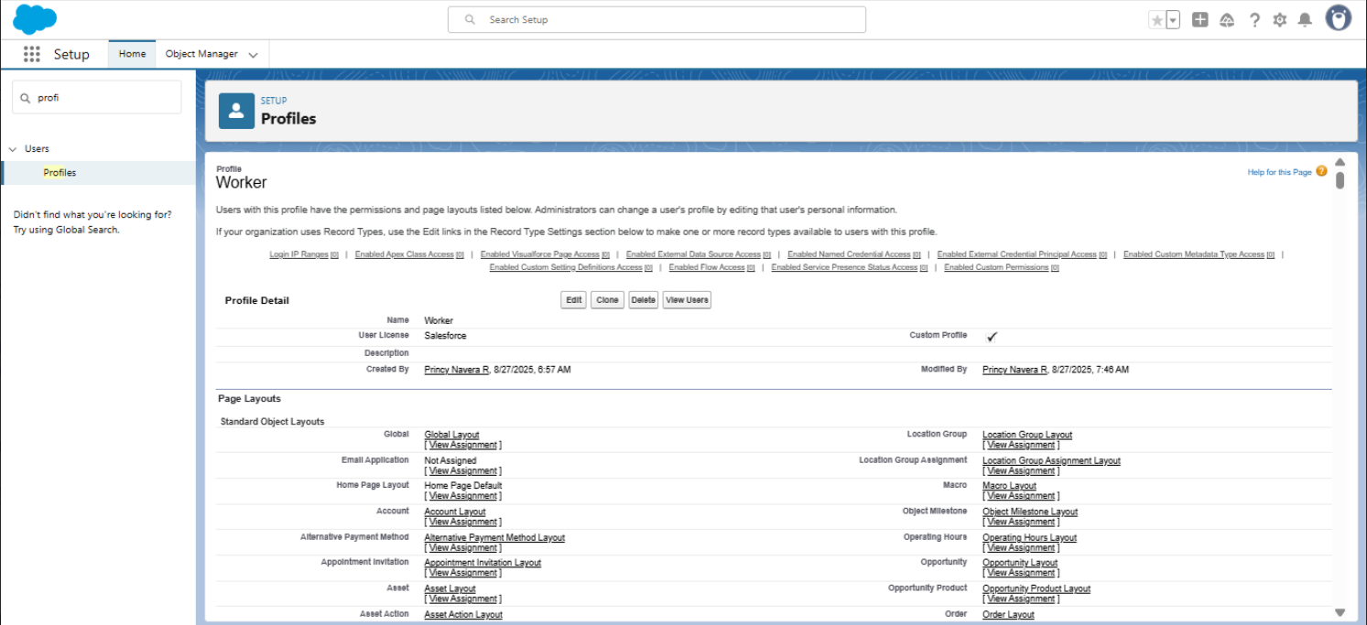

* **Roles**

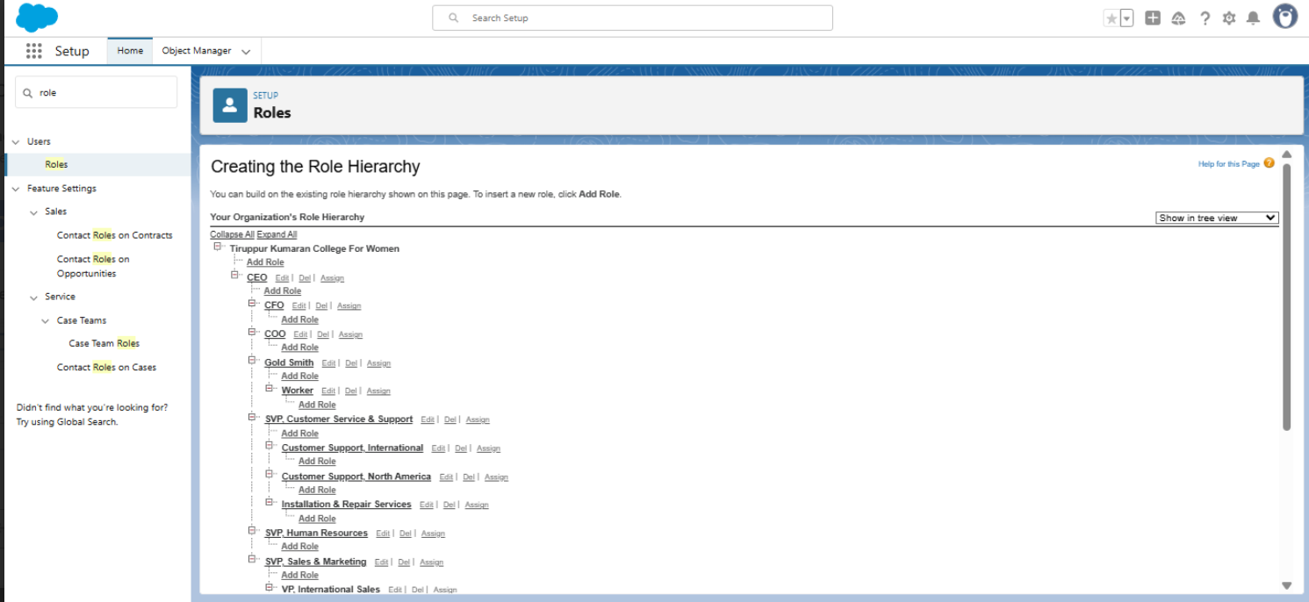

* **Users**

Create User

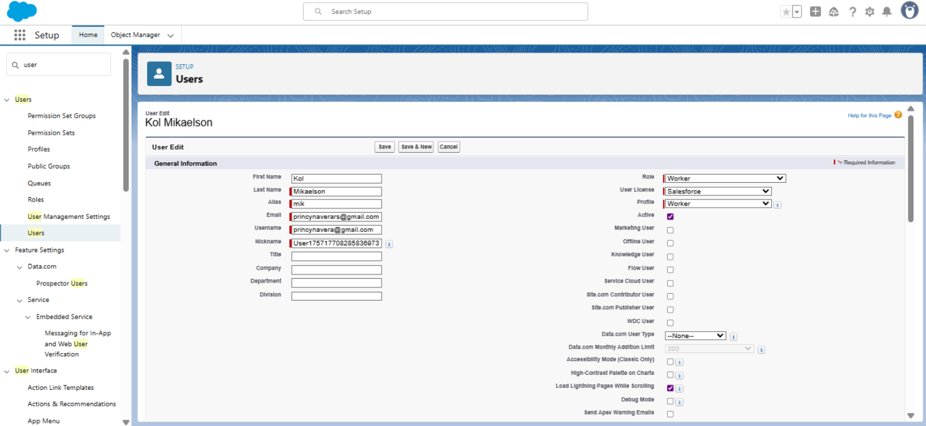

* **Page layouts**

**To Create a Gold And Silver Page layout**

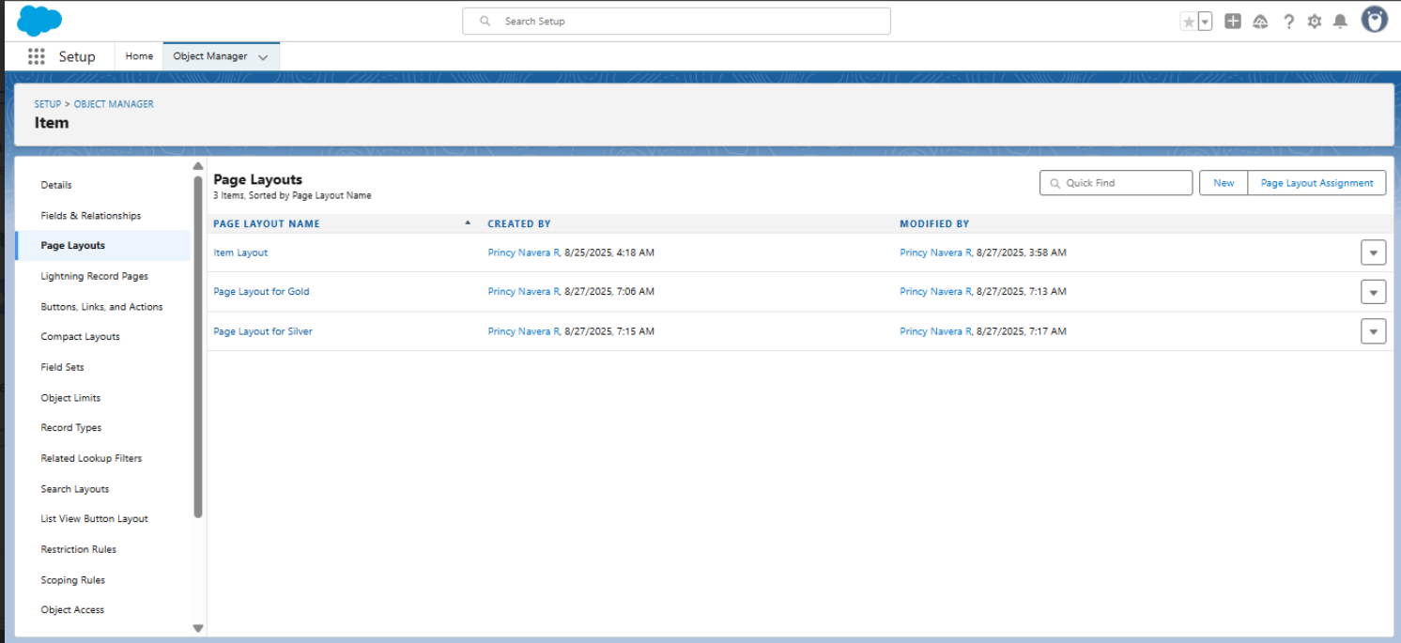

* **Record Types**

**To create a Record Type**

* **Trigger**

**Create a Trigger Handler class**

Create the trigger

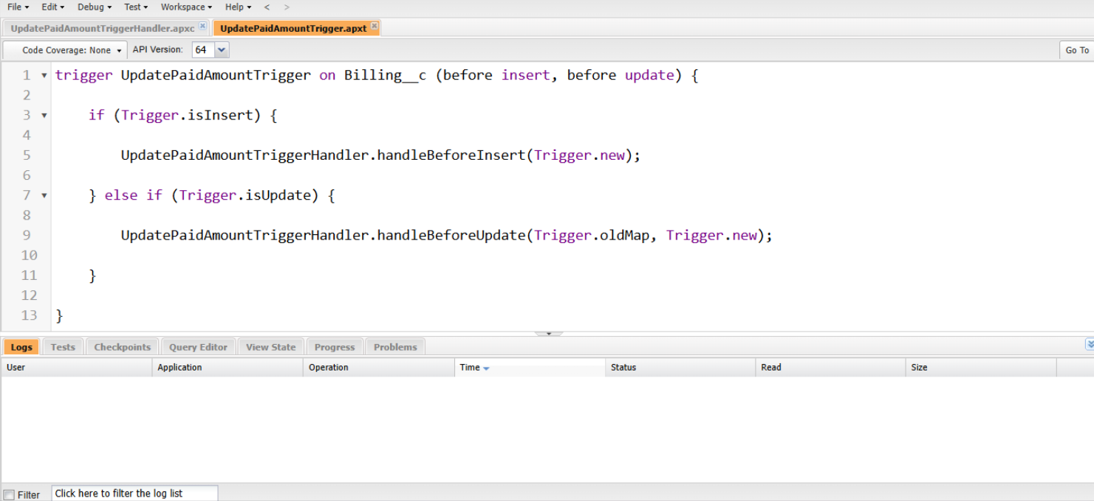

* **User Adoption**

**Create a Record (Jewel Customer)**

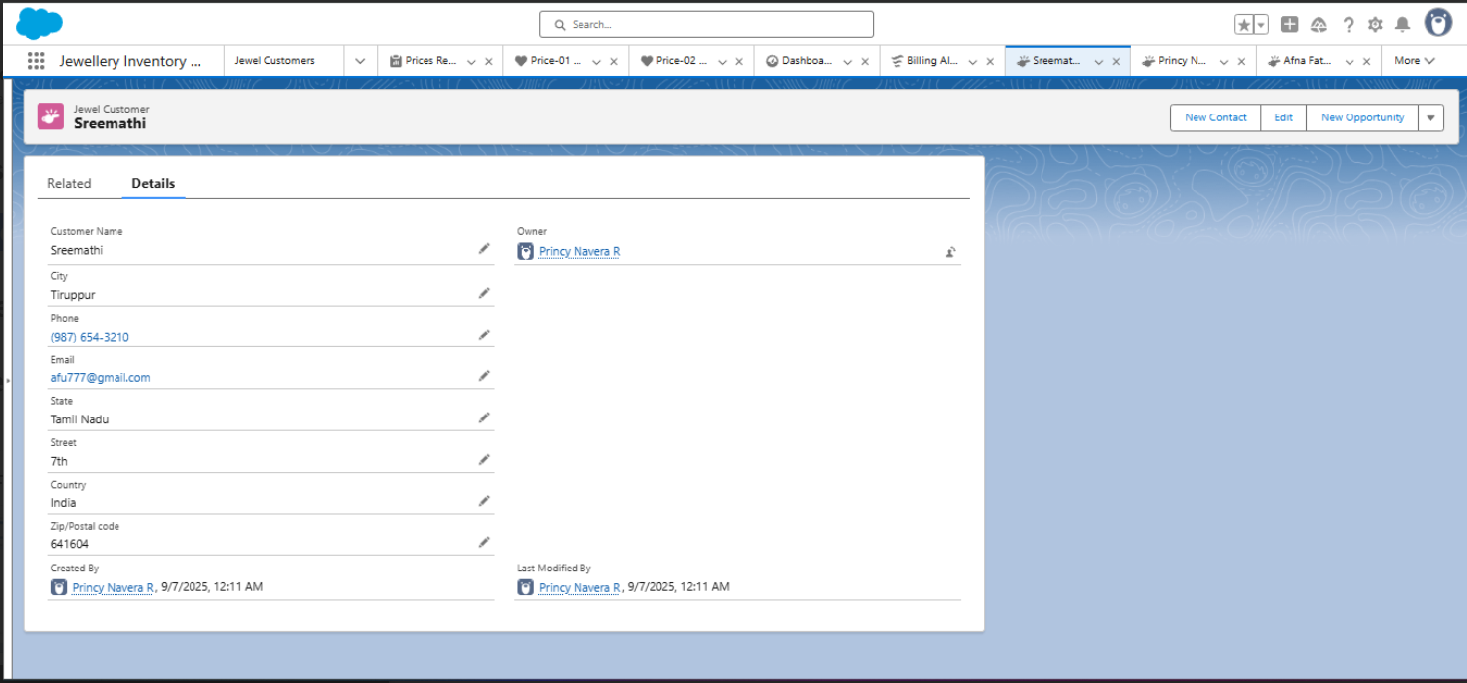

**View a Record (Jewel Customer)**

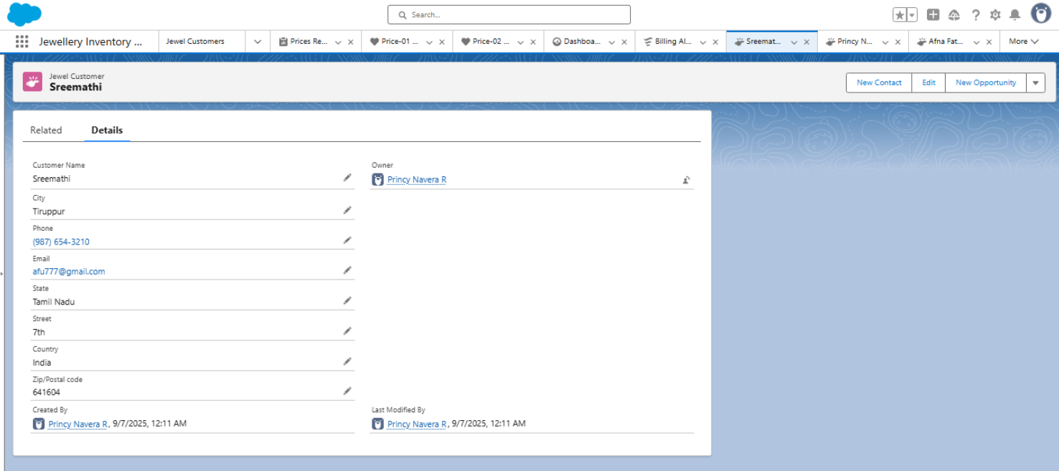

**Delete a Record (Jewel Customer)**

* **Reports**

**Create Report**

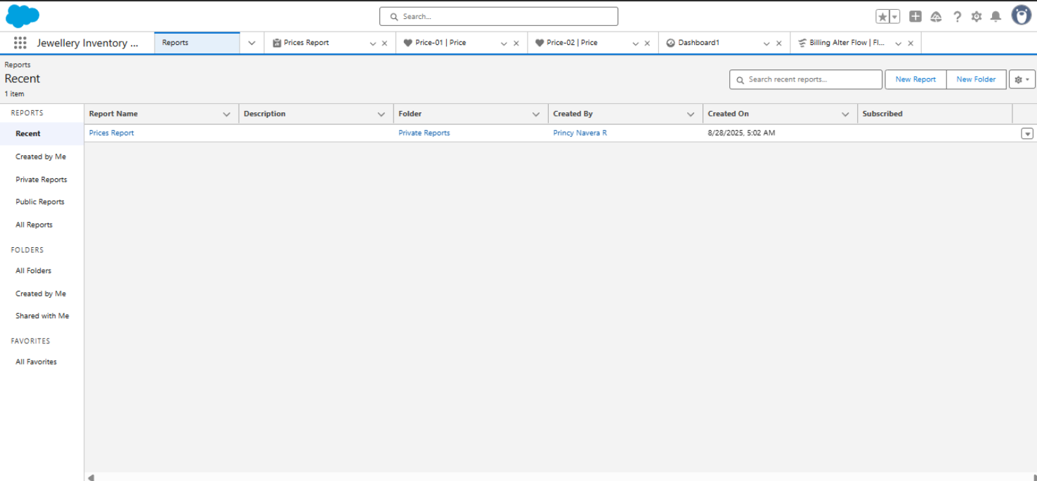

**Reports**

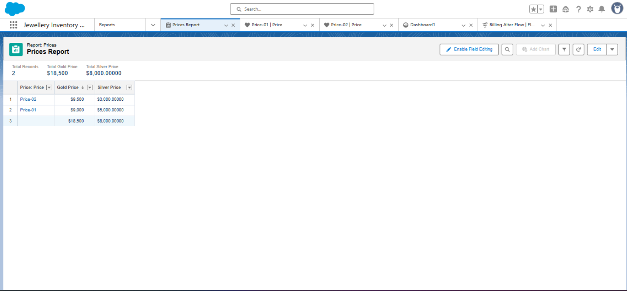

* **Dashboards**

**Create Dashboard**

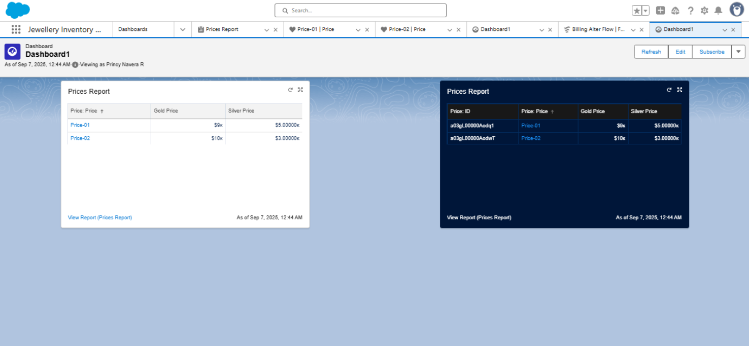

* **FLOW**

**CREATE FLOW**

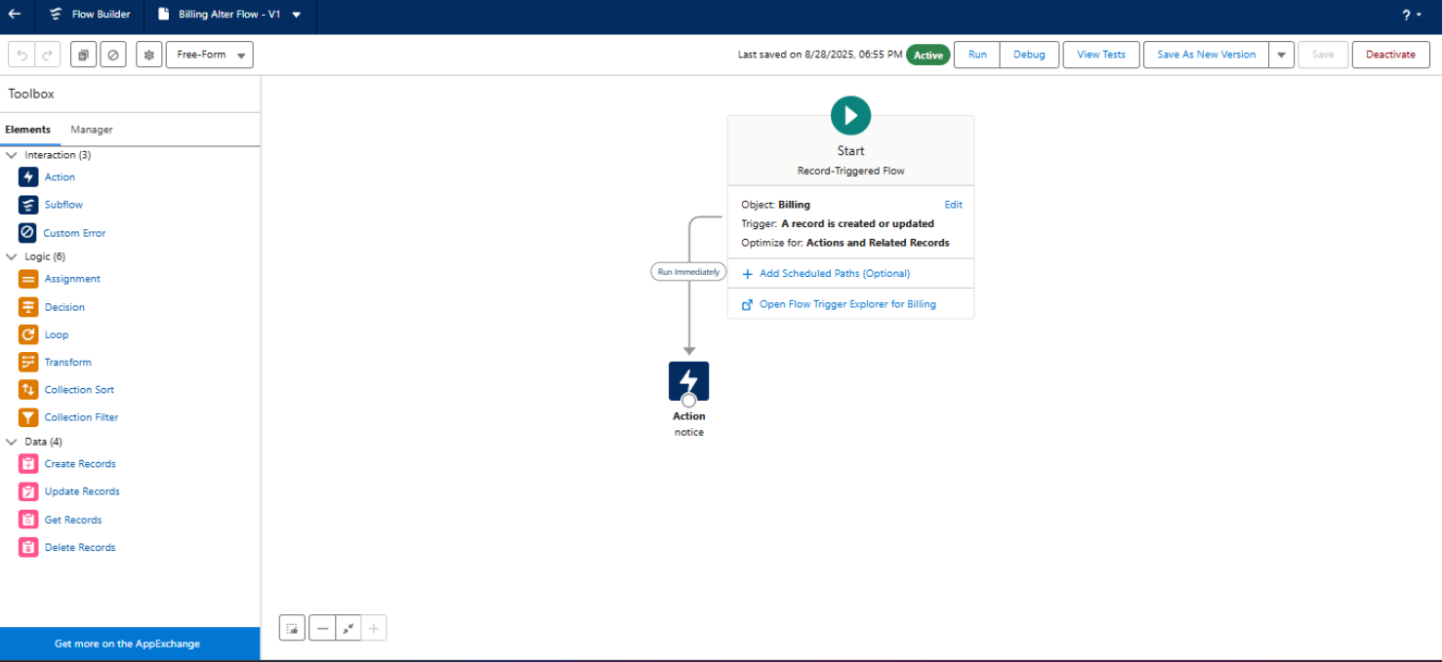

THIS IS THE LAST STEP OF CRM APPLICATION FOR JEWEL APPLICATION.

NOW THE JEWEL INVENTORY SYSTEM IS ACTIVATED.

**CONCLUSION**

THE CRM APPLICATION FOR JEWEL MANAGEMENT HAS BEEN SUCCESFULLY DEVELPOED AND CONFIGURED BY CREATING CUSTOM OBJECTS , FIELDS , PROFILES , ROLES ,USERS,PAGELAYOUTS,RECORD TYPES,PERMISSION SETS ,TRIGGERS ,REPORTS, DASHBOARDS AND FLOWS. THIS IMPLEMENTATION ENABLES EFFICIENT TRACKING AND MANAGEMENT OF JEWELLERY INVENTORY, CUSTOMER DETAILS AND RELATED OPERATIONS. THE SYSTEM IS NOW FULLY FUNCTIONAL AND READY FOR USE, PROVIDIND A STREAMLINED, USER FRIENDLY SOLUTION FOR JEWEL MANAGEMENT AND SUPPORTING IMPROVED BUSINESS PROCESSES.